Accessible Physical Structure and Communication Service Directive for People with Disabilities, 2069 BS (2013 AD)
(Approved by Government of Nepal (Council of Ministries) on 2069/11/06 BS (February 17, 2013 AD)

Contents
Preamble:
Chapter-1
Preliminary
1. Short Title and Commencement:
2. Definition
Chapter-2
Regarding making external service and benefit accessible
3. Making public road and Sidewalk accessible:
4. Making recreational parks accessible:
5. Making playground accessible:
6. Making public toilet accessible:
7. Making public building accessible:
8. Making bus park accessible:
9. Making passenger loading zone accessible:
10. Making public transportation accessible:
11.Making hotel and restaurant accessible:
Chapter-3
Regarding making internal services and facilities accessible
12. Making building’s passage and lobby accessible:
13. Making other internal services and facilities accessible:
Chapter-4
Arrangement regarding making information and communication accessible
14.Making communication system accessible:
15.To be arranged an interpreter:
16.News and notice to be broadcasted in sign language too:
17.Making other notices accessible:
Chapter-5
Accessible infrastructure and standard
18.Slope ramp for wheelchair:
19.Curb ramp for wheelchair:
20. Door:
21. Required space for rotating the wheelchair:
22.Bathroom:
23. Public tap and washing basin:
24. Table, counter and others:
25. Public telephone booth and ATM service:
26. Vehicle parking:
27. Conference hall and cinema hall:
28. Ladder:
29. Lift:
30. Water tap:
31. Toilet:
32. Sidewalk:
33. Tactile blocks:
Chapter-6
Miscellaneous
34. Electricity pole, signboard, telephone booth, notice and information board to be kept without barrier:
35. Reasonable Accommodation be available:

Preamble:
By arranging appropriate ramp, door, window, tactile block and Braille in public physical structures like government offices, schools, universities, hospitals, health care facilities, religious spaces, workplace, public road, Sidewalk, passenger waiting place, parking lanes, recreational places, playground, conference hall, cinema hall and business complexes, residential buildings, hotel and restaurant, ATM services etc these are opened for public use to be accessible for people with disabilities for their easy mobility and utilization;
to promote access of people with disabilities to public communication and information services like television, radio etc as well;
to increase access by removing barriers to people with disabilities to establish uniformity in constructing services and facilities by fixing required standards for enabling them to utilize their civil, political, economic, social, cultural rights and entitlements;
mentioned in Convention on the Rights of People with Disability (CRPD) which was ratified by Nepal on 2066 Poush 12 BS (December 27, 2009 AD) by legislative parliament (endorsed in UN on 7 May, 2010), Nepal’s Interim Constitution 2063 BS (2006 AD), Article 6.4.1, 6.4.2 of National Policy and Plan of Action Regarding Disability 2063 BS (2006 AD) and other prevailing laws; as it is desirable for their full and effective participation in development process, Government of Nepal has drafted the following Accessible Physical Structure and Communication Service Guideline for People with Disabilities, 2069 BS (2013 AD).

Chapter-1

Preliminary

- Short Title and Commencement: (1) The title of this Guideline shall be “Accessible Physical structure and Communication service Guideline for People with Disabilities, 2069 BS (2013 AD)”.

(2) These guidelines shall come into force immediately.

2. Definition: Unless the subject or context otherwise requires, in these guidelines:

(a) “People with disability” means those who have long-term physical, mental, intellectual or sensory impairments or functional impairments which in interaction with various barriers may hinder their full and effective participation in society on an equal basis with others.
(b) “Public physical structure” means all kinds of government, non-government and private physical infrastructure these are being constructed or being opened for consumption and utilization by all people.
(c) “Public building” means any government, non-government or private buildings these are built or used for public utilization or delivery of consumable materials, services, facilities, benefits, opportunities etc for all people.
(d) “Slope ramp” means inclined pathway made for wheelchair entry in a building.
(e) “Curb ramp” means inclined path made for wheelchair entry between low and high level of ground.
(f) “External service and benefit” means those services and benefits these are used by a person while he or she is outside of any building or residence like road, Sidewalk, recreational parks, playground, parking space, passenger waiting place, bus park, public toilet, ATM service, public tap, public telephone service, traffic light, overhead bridge etc.
(g) “Internal service and benefit” means those internal structures like door, ladder, passage, toilet, bath room, table, rack, bed, window, desk, bench etc and related benefits inside in any public or private building.

Chapter-2

Regarding making external service and benefit accessible
3. Making public road and Sidewalk accessible: Government of Nepal, local bodies, other concern agencies or institutions should make following arrangements while constructing or being constructed by, public road and Sidewalk to be readily accessible for people with disabilities:
(a) All public roads should be made accessible for equal and convenient mobility of people with disabilities.
(b) For requisite of Section (a), all newly built roads should be constructed shall be completely accessible for mobility of people with disabilities including people who use wheelchair, people who use crutches, people who use artificial limbs, people who are blind, little people etc and existing barriers in existing roads for movement of people with disabilities should be removed.
(c) Tactile blocks should be laid in Sidewalk and road crossing place of newly constructed main big roads for free movement of people who are blind and in case of existing roads existing roads, tactile blocks should be laid during maintenance work.
(d) Sidewalk of newly constructed public major roads should be made accessible for movement of all people with disabilities and all kinds of barriers or hurdles in Sidewalk of existing roads for movement of people with disabilities should be removed.
(e) Sidewalk should be made accessible in such a way that people with disabilities including people who use wheelchair can easily and freely move with their assistive devices.
(f) Ramps should be made at different places including road crossing place and the place to go to another Sidewalk from one Sidewalk.
(g) While connecting new traffic lights at major roads, to cross the road by people who are blind, a specific type of light with siren to inform during green light on should be connected compulsory and similarly such kind of arrangement should also be made in existing roads.
(h) As it is impossible for a wheelchair user and inconvenient for people who use assistive devices like crutches, caliper to cross the road via overhead bridge, an appropriate alternative arrangement shall be made for them.
4. Making recreational parks accessible: Government of Nepal, local bodies, other concern agencies or institutions; during construction, being constructed by or given approval for private sector to construct it; easy mobility and access of people with disability including people who use wheelchair, people who are blind, people who use crutches, and little people shall be ensured to physical structures inside parks. Similar kinds of old structures should also be made accessible for people with disabilities gradually.

5. Making playground accessible: Government of Nepal, local bodies, other concern agencies or institutions should make following arrangements while constructing or being constructed the playground to be accessible for people with disabilities:
(a) Playground shall be developed, constructed and improved in such a manner that people with disabilities can also play and watch the game there.
(b) For requisite of Section (a), an arrangement should be made by constructing ramp to get into the needy places of playground with wheelchair and other essential facilities available in premises of playground like public toilet, canteen, covered hall etc shall be made accessible for people with disabilities.
(3) Specific portion of audience hall shall be assigned for people with disabilities and made it accessible with various facilities including ramp to reach the place by people who use wheelchair, people who use crutches or people with mobility impairment. Out of total capacity of the playground, 5% seats shall be allocated for people with disabilities. If the audience hall is divided into different categories, each category’s seat should be made accessible to be usable by people with disabilities.

6. Making public toilet accessible: While constructing new public toilet and travel path to the toilet, door, inner spaces of the toilet and purity space etc, Government of Nepal, local bodies, other concern agencies or institutions should make them accessible for all people with disabilities including people who use wheelchair, little people, people who are blind, people who use crutches.

7. Making public building accessible: Government of Nepal, local bodies, other concern agencies or institutions; during construction or being constructed public buildings opened for general people, should make the following arrangements to be accessible for people with disabilities:
(a) To purchase required materials or to get other services and opportunities by mobility of people with disabilities themselves freely in the market, ground floor of both sides buildings of the road and surface of road or Sidewalk should be built parallel or the height should be minimum and curb ramp should be arranged to get the services by people who use wheelchair.
(b) Link road from road or Sidewalk to premises of any public building and public building or structure built by private, semi-governmental or non-governmental bodies for the requisite of public use or utility shall be constructed in such a manner that there shall not be any barriers to all kinds of people with disabilities including people who use wheelchair, little people, people who are blind and people who use crutches etc.
(c) At public building which is being used for requisite of providing direct services to public like ministry or department, bank, hospital, office related to information and communication, any government office, big shopping centre, political parties’ offices etc, an arrangement should be made to provide facilities from ground floor as much as possible and if these services are available in, lift or ramp should be arranged mandatorily.
(d) Main entrance to toilet, service counter, inquiry, reception etc inside public building or its premises should be made accessible for people with all kinds of disabilities including people who use wheelchair, little people, people who are blind and people who use crutches etc.
(e) To get various services available inside public buildings by people with disabilities; essential notice and information available for people regarding availability of various services inside public buildings or it premises should also be available in Braille script.
(f) As far as possible, at least one accessible lift should be kept compulsorily in two or more than two storey public buildings.

8. Making bus park accessible: While constructing or being constructed public bus park by Government of Nepal, local bodies, other concern agencies or institutions; ticket counter, vehicle waiting spaces, toilet inside premises, platform for passengers to get into bus etc should be made accessible for all people with disabilities including people who use wheelchair, little people, people who are blind and people who use crutches.

9. Making passenger loading zone accessible: While constructing or being constructed passenger loading zone, Government of Nepal, local bodies, other concern agencies or institutions should make following arrangements to be accessible for people with disabilities:
(a) Passenger loading zone for public vehicle in street should be made accessible and user friendly for all people with disabilities including people who use wheelchair, little people, people who are blind, people who use crutches etc.
(b) For requisite of Section (a), special attentions shall be paid in constructing height of the zone from street, arrangement of ramp, required space for wheelchair, seating place for waiting vehicle etc.

10. Making public transportation accessible: (1) When transportation entrepreneurs purchase new public buses, an accessible bus for people with disabilities should be purchased.
(2) Revenue discount as stipulated in Economic Act shall be provided on importing or purchasing disability friendly public transportation in accordance with Sub-Section (1).
(3) To make old public buses be accessible, Government of Nepal will encourage entrepreneurs by making various arrangements including tax exemption as stipulated in Fiannce Act.

11.Making hotel and restaurant accessible: When concern agency, organization or person construct or being constructed the hotel and restaurant, the following arrangement should be made to be accessible for people with disabilities:
(a) While operating hotel and restaurant in ground floor of rental building, it should be arranged in such a manner that people with disabilities including people who use wheelchair, people who use crutches etc can easily reach at least upto billing counter, dining hall and toilet without any barriers.
(b) In hotel and restaurant having lift facility, there should not be any physical barriers for people who use wheelchair to reach upto the lift and enter into it.

Chapter-3

Regarding making internal services and facilities accessible

12. Making building’s passage and lobby accessible: (1) While constructing business complexes, residential buildings for government or public purpose or open for public use, concern organization or person should construct passage and lobby of such buildings keeping in mind free and easy mobility of people with disabilities.
(2)For requisite of Sub-Section (1), such arrangement shall be made during the maintenance and improvement of old buildings too.

13. Making other internal services and facilities accessible: (1) While constructing buildings for public use, concern organization or person should make its entrance, passage, door, lobby, ladder, bath room, toilet, kitchen, bed room as well as other facilities available inside the buildings accessible for people with disabilities.
(2) While operating buildings for all private, non-governmental and governmental educational purposes including school, university, the concern organization and person should make its entrance path to the premises, toilet, door, ladder, class room, seating arrangement in class room, library, administrative office, conference or meeting hall, stage to perform various programmes, canteen, laboratory, computer lab etc of the building accessible for all people with disabilities including people who use wheelchair, people who use crutches, people who are blind etc.

Chapter-4

Arrangement regarding making information and communication accessible

14.Making communication system accessible: Accessible communication system shall be guaranteed for people who are deaf and hearing impairments who have barriers to communication.

15.To be arranged an interpreter: (1) Any person, organization, group or agency has to arrange an interpreter themselves if they need to do communication or idea sharing with deaf and people with hearing impairment for developing accessible communication system and practice.
(2) To ensure speech freedom of deaf people in public assembly, function, meeting, gathering etc or to protect their right to know about the ideas or activities shared by others in such programmes, the organizing person, organization or agency should compulsorily arrange an interpreter.

16.News and notice to be broadcasted in sign language too: (1) Each news channel, television broadcasting organization should broadcast news in sign language at least once in a day and headline of each news bulletin should be simultaneously broadcasted in sign language too.
(2) While broadcasting any essential public notices from government or private sector through television, it should be broadcasted together in sign language too.
17.Making other notices accessible: Essential public notices being put up by concerned organization in public and private places like class room number and name in school, name of section or department outside office and related staff’s name, room number or name in hotel, citizen charter keeping outside of public office, notice to separate female and male toilet etc should be put up on an appropriate place and height so that people who are blind can easily find them while touching.

Chapter-5

Accessible infrastructure and standard
18.Slope ramp for wheelchair: (1) The concern agency or person should arrange a slope ramp for wheelchair parallel to ladder-steps for entry into the public buildings to be accessible for people with disabilities.
(2) The slope ramp according to Sub-Section (1) might be winding or straight depend on availability of the space and might be cemented or can be made of wood or soil depending on available resources.
(3) Ramps can be made movable (putting in and getting off) according to need.
(4) While constructing slope ramp for wheelchair, the concern agency or person should comply with the following standard to be accessible for people with disabilities:
(a) Ramp should be less inclined as much as possible to roll the wheelchair.
(b) For newly constructing public building, slope of the slope ramp should be in 1:15 ration in general. If the ramp is being built by repairing old building or being built ramp during the re-construction in the same place, the ramp can be built in ration of 1:8 to 1:12 depending upon the situation and availability of the space.
(c) All entry routes including premises of newly constructing public buildings should be compulsorily accessible for people who use wheelchair. In case of old public buildings, at least one entry route should compulsorily be accessible for people who use wheelchair.
(d) The width of ramp’s space rolling the wheelchair should be at least 36 inch (915mm) excluding space of grab bars.
(e) The length of a single run of any ramp should be maximum 9m or not more than 30ft. So, a Level Landing should be put after each 30ft length and next part shall be made if needed.
(f) The grab bars in both side of the ramp are compulsory if the ramp is made more than 6 inch high.
(g) Level landing should be made in upper and lower parts of single run of the ramp. The width of the level landing should also be at least 36 inches (915mm) and the length should be at least 60 inches (1524mm).
(h) The height of hand railing made in both sides of the ramp should be 90cm for adult and 70cm for children from surface of the ramp. Similarly, 5 to 10cm high side rail in both sides should be made in each ramp to stop wheels going outside while rolling it by wheelchair user.
(i) While constructing surface of the ramp, it should be constructed in such a way that the tires of a wheelchair and feet of wheelchair pushing assistant should not be slipped.

Wheelchair Ramp
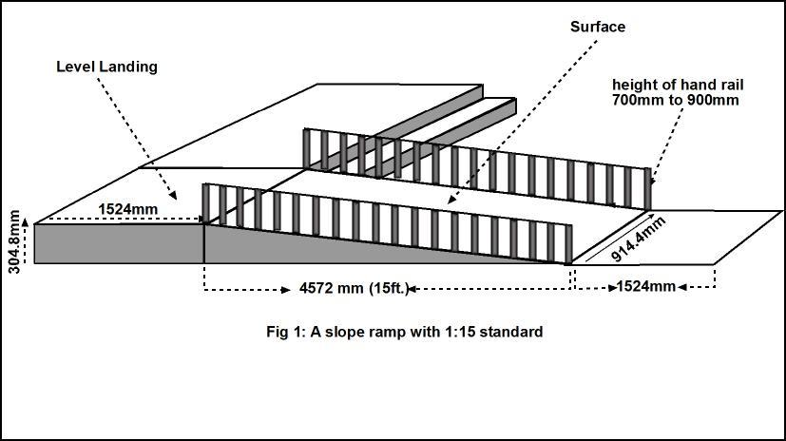

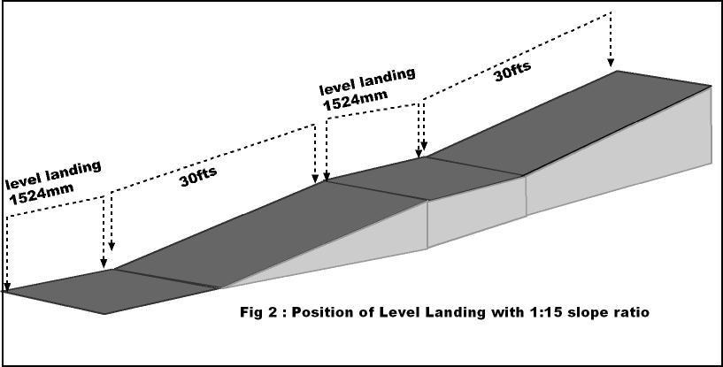

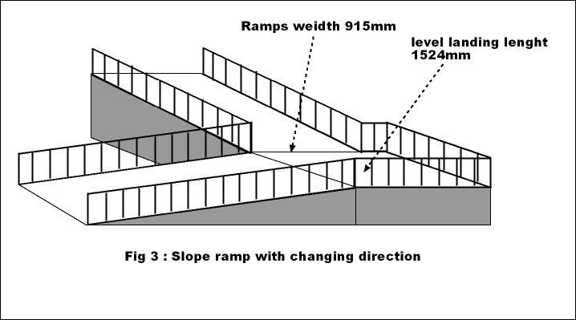
19.Curb ramp for wheelchair:
(1) The concern agency or person should build a curb ramp between high and low surface in general, specifically while getting down from Sidewalk to road, getting in from road to Sidewalk or in zebra crossing to avoid barriers for movement of any wheeled vehicle including wheelchair.
(2) The concern agency or person should build a curb ramp also in crossroad, juncture of four roads, parking lanes, the place made to cross the road, the link path to enter into the buildings built in side of the road or Sidewalk etc.
(3) While building the curb ramp, the following standard criteria should follow to be accessible for people with disabilities:
- Like in slope ramp, the standard criteria for slope of curb ramp should not be less than 1:15 ration in case of new design and 1:12 ration in case of maintenance of old design or re-construction.
- The width of curb ramp should be at least 36 inches (915mm) for wheelchair.
- While building curb ramp to join main road and footpath; if the curb ramp is made by cutting some portion of the Sidewalk, the elevation of flared sides of the curb ramp should be at least in 1:10 ratio.
- If the curb ramp with flared sides is being built between Sidewalk and road, at least 36 inches (915mm) width space should be available to roll down wheelchair from Sidewalk to the ramp or to rotate the wheelchair in any direction after getting it into the Sidewalk from road via curb ramp.
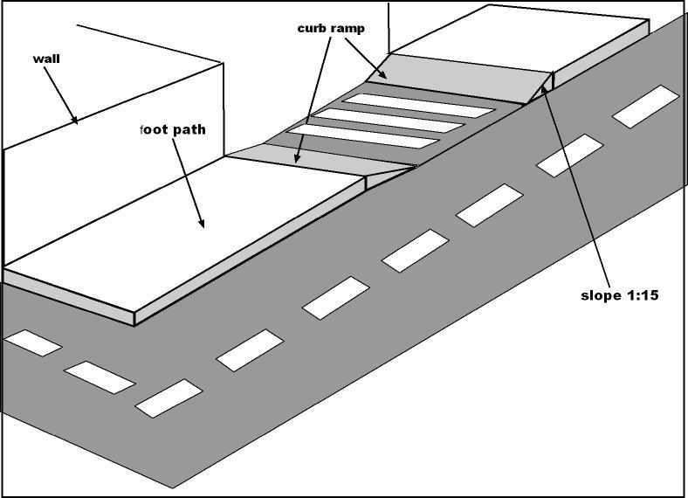

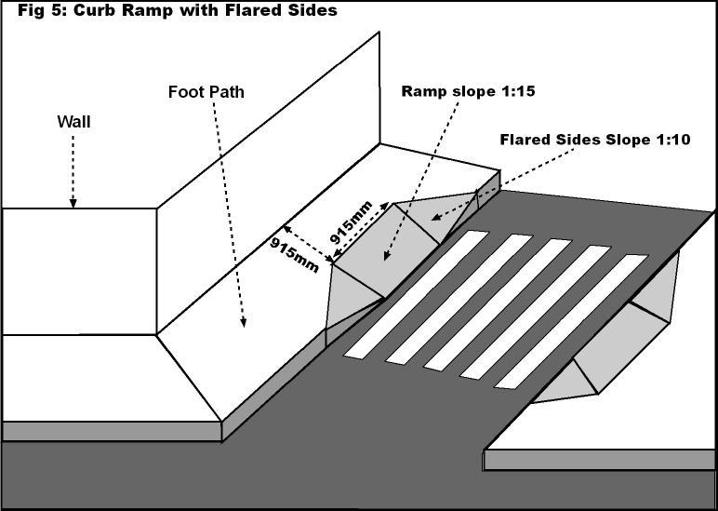

20. Door:
(1) Necessary doors made in public building, its premises or any physical structure built for public purpose should be barrier free for wheelchair entry.
(2) The concern agency or person should follow the following standards while building the doors to be accessible for people with disabilities:
(a) When the leaves of door are opened in 90 degree or completely opened, the clear width of the door should be 32 inches (813mm).
(b) The door which is being made having two independent leaves and at least one leaf is used for in and out, there should be at least 32 inches (813mm) clear width while it is opened in 90 degree.
(c) The door which needs more than 5 pound pushing force to open it shall not be considered accessible.
(d) While keeping latch, handle, knot or key bolt to open or close the door from inside or outside, the height from floor to that place should not be more than 42 to 48 inches (1067mm to 1219mm).
(e) Enough space should be available inside and outside door for pulling and pushing or rotating the wheelchair during opening or closing the door.
(3) Whatsoever written in other Sectons, the door built according to following manner shall not be considered accessible:
(a) Excessive force is required to open the leaves or door with spring tight self closing leaves.
(b) The door which does not have enough space available to open and close it from outside or inside with sitting on wheelchair or standing on crutches.
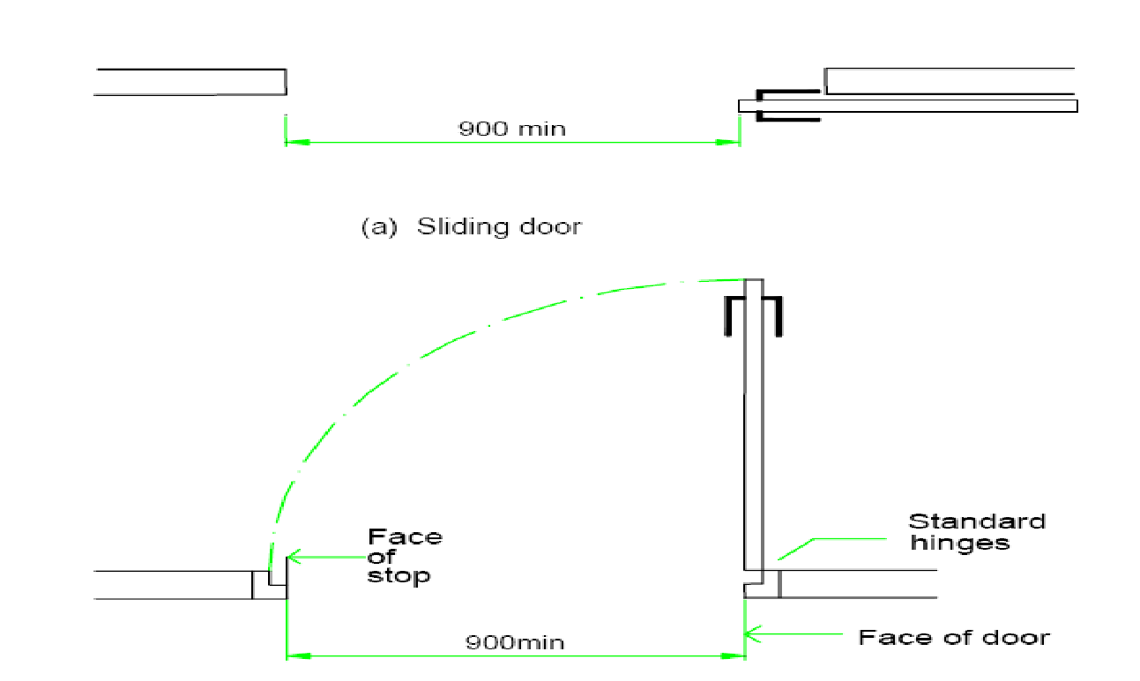

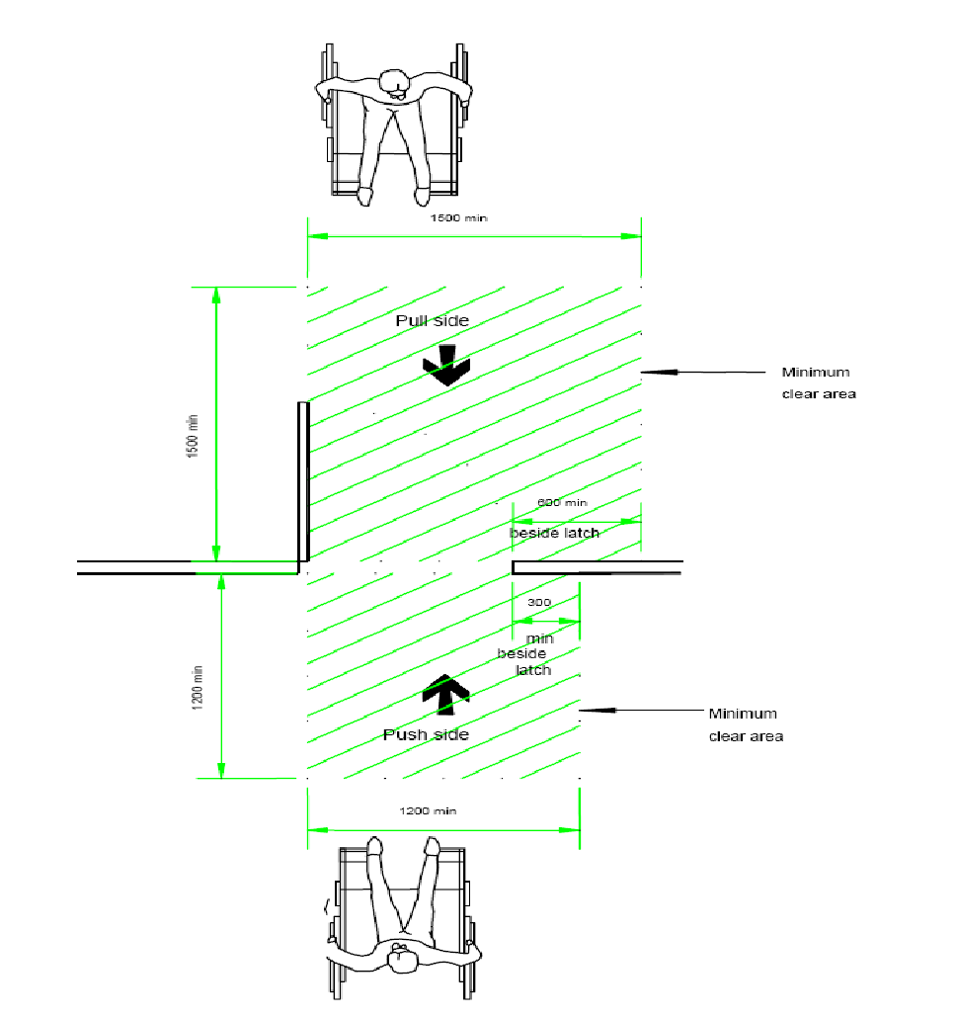

21. Required space for rotating the wheelchair: (1) While moving with wheelchair, there should be enough space to rotate the wheelchair left and right side or opposite direction in different circumstances.
(2) Generally, there should be space with at least 71 inches (1,800 mm) diameter to rotate a wheelchair in 180 degree.
(3) Enough space should be available in Sidewalk, public toilet, bath room, public building’s passage, corridor or veranda, ATM room, public telephone booth, place between two lines of racks in departmental stores, place between lines of book racks in library, gap place between right and left desk and chair in class room etc so that a wheelchair can easily be rotated there.
(4) Since at least 48 inches (1200mm) width space is required to roll one wheelchair easily in Sidewalk, road, passage or corridor of building, lobby etc, needy spaces should be arranged to rotate the wheelchair in these places, to cross the another wheelchair coming from opposite direction and for pedestrians’ easy mobility along with wheelchair.
(5) The width of corridor and passage of public buildings should be at least 71 inches (1,800mm) to cross two wheelchairs without any barriers.
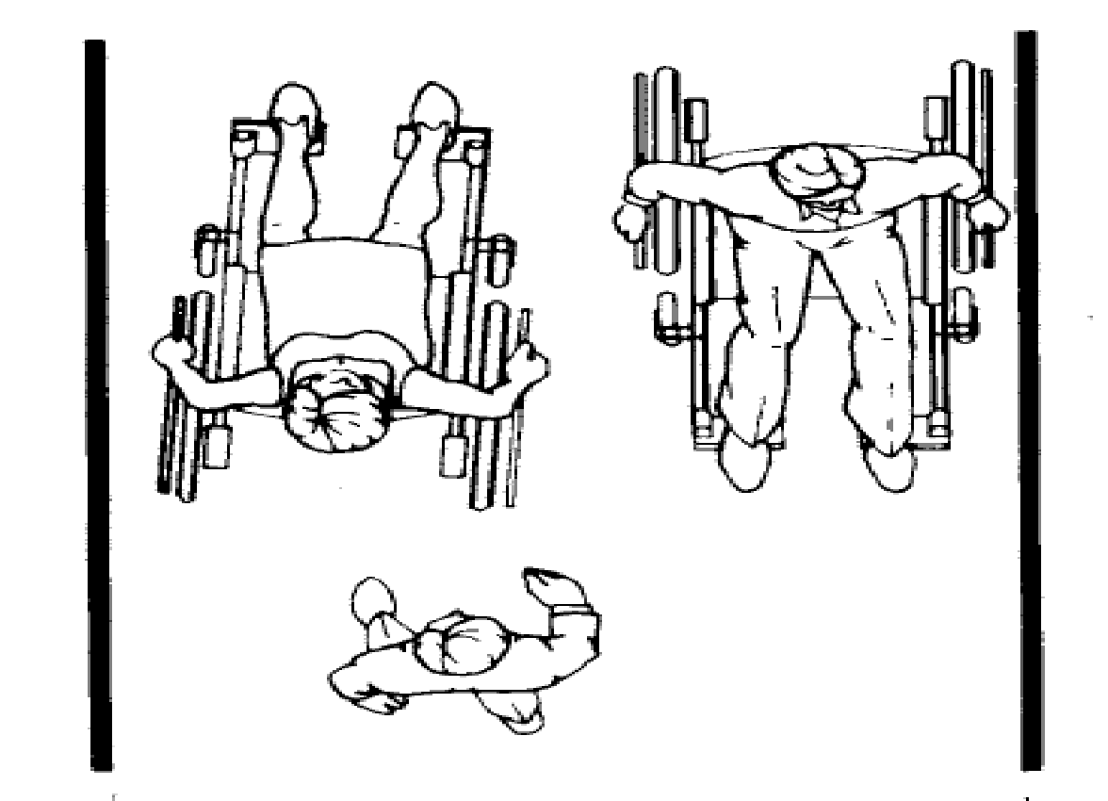

22.Bathroom: (1) Public bathrooms or bathrooms made in residential guest houses should be user friendly and accessible for all people with disabilities including people who use wheelchair.
(2) While building public bathrooms or bathrooms made in residential guest houses, the following standard should follow to be accessible for people with disabilities:
(a) Inner portion of an accessible bathroom should be at least 92.5 inches long and 71 inches wide.
(b) The door of a bathroom should be at least 32 inches (813 mm) wide.
(c) If a ladder-steps need to be used reaching the door of the bathroom, a ramp should be arranged and if the ladder-step is not required to use, there should not be any barriers to roll wheelchair.
(d) A space with 71 inches (1800 mm) diameter should be available to rotate the wheelchair inside the bathroom.
(e) Shower controls used to open and close the showers to be available in bathroom should keep at maximum height of 40 inches from floor. The shower controls used to open and close the shower should be easily usable even by sitting on wooden seat or chair on the floor.
(e) The space for cloth hook, towel stand, and soap case place should be at maximum height of 39 inches to 47 inches (1000 mm to 1200 mm) from ground surface.
(f) Grab rail in wall should be managed in bathroom making easier for people who use wheelchair or people with disabilities to stand and sit. The grab rail should be at maximum height of 30 inches from the ground surface.
(g) There should be an alarm bottom at maximum height of 15 inches from the ground surface which can be used easily in emergency if person with disability is felt down or an accident happened inside bathroom.
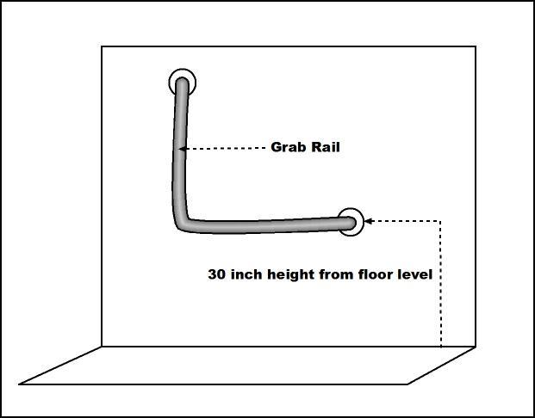

23. Public tap and washing basin: (1) Any tap, wash basin etc built for public purpose should be made accessible for all people with disabilities including people who use wheelchair, people who use crutches, little people, people who are blind etc.
(2) For requisite of Sub-Section (1), special attentions should be paid for arrangement of a ramp to reach a wheelchair upto the public tap, height of tap, type of tap, the place to keep personal hygienic materials etc.
(3) The following standard should be followed while building wash basin to be accessible for people with disabilities:
(a) While connecting wash basin for people who use wheelchair, the distance between inner space of the basin and its side wall should be at least 460 mm.
(b) Top edge of the basin should be at maximum height of 31 to 33 inches (800 mm to 840 mm).
(c) There should be space available below the basin to insert knee including front part of the wheelchair. For this, there should be at least 750mm wide, 680 mm height between surface and bottom of the basis and 200 mm inner space for adjusting knees.
(d) The mirror kept just above the basin should be at maximum height of 1000 mm from ground surface.
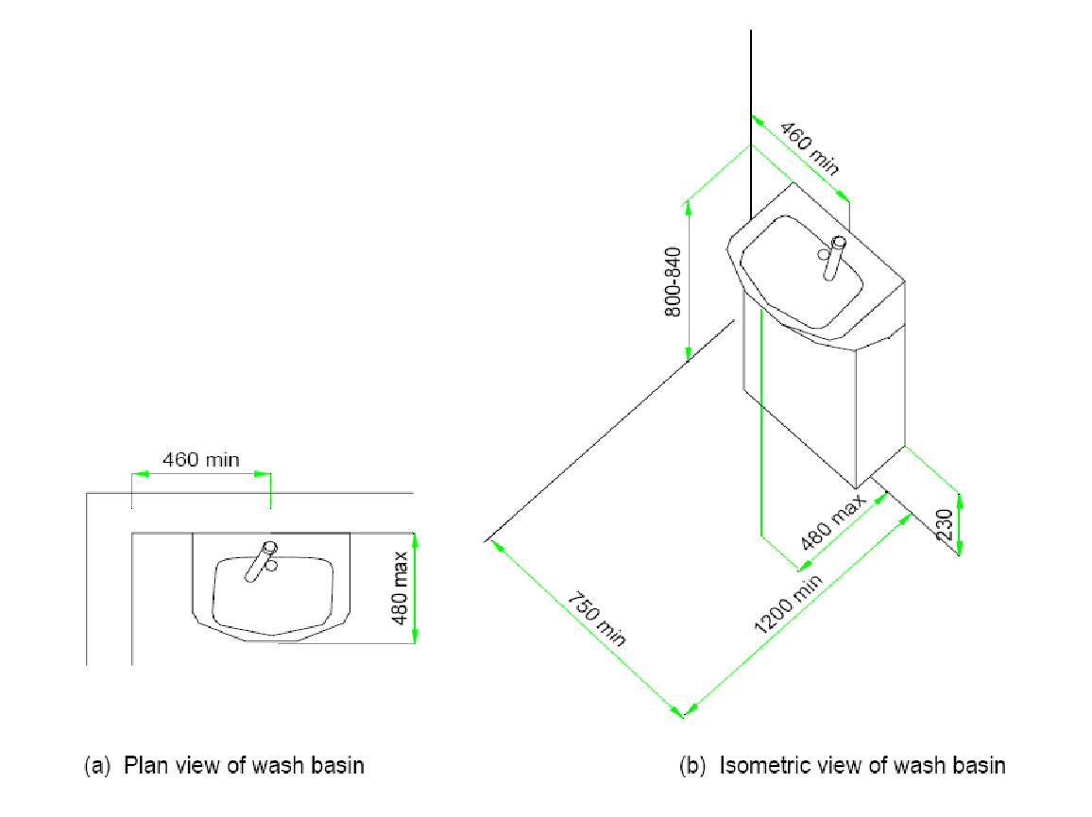

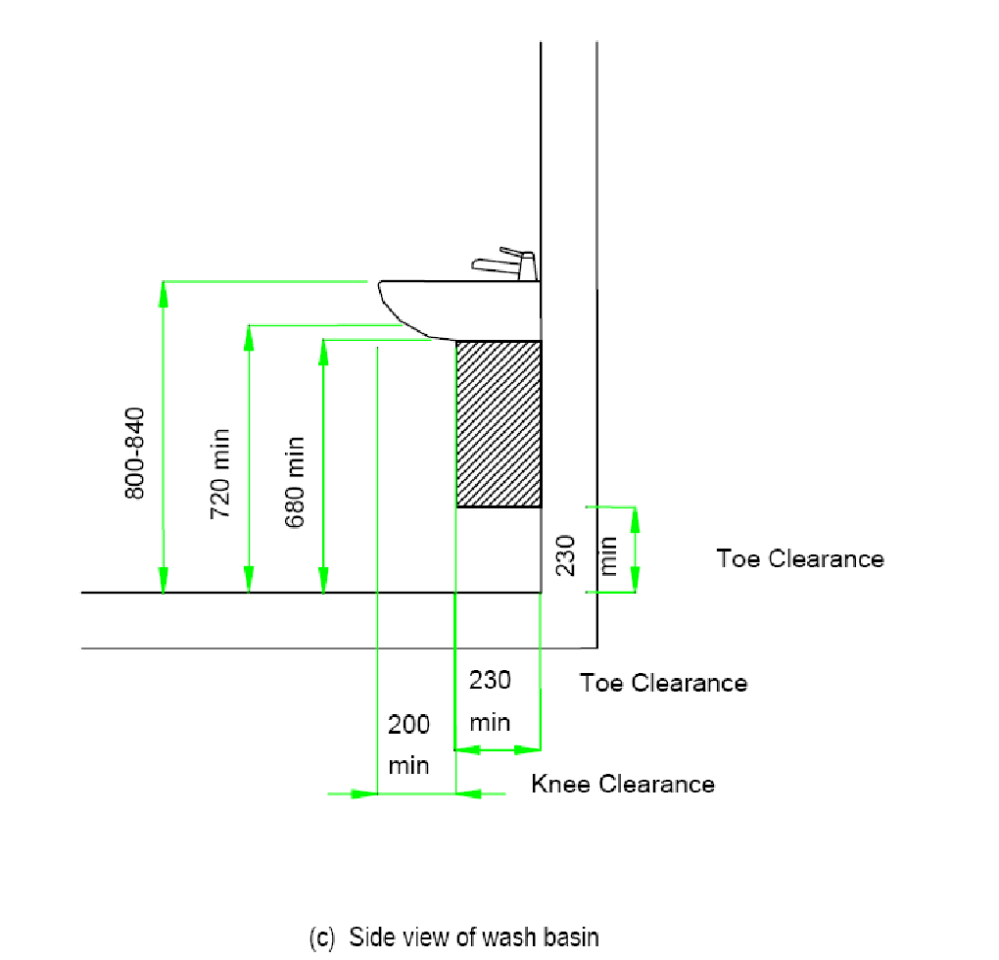

24. Table, counter and others: The concern agency or organization should make following arrangements for their internal service and benefits including workplace to be accessible for people with disabilities:
(a) A minimum 900 mm x 1200 mm space should be available to use the table, working desk, study table etc at office for people who use wheelchair.
(b) For requisite of Sub-Section (a), the height of that kind of table should be maximum 762 mm to 800 mm.
(c) To do work easily on table or desk by people who use wheelchair, minimum 480 mm deep and 900 mm wide space be available to insert front part of the wheelchair and knees of the person beneath the table or desk.
(d) Cloth hanging hook kept in the wall of living room should be at maximum height of 42 to 48 inches from the ground surface for people who use wheelchair.
(e) Service counter that being built at government, non-government or private office to provide public services, ticket counter at cinema hall, reception, desk for getting or filling application form, inquiry or information desk, registration desk etc should be at maximum height of 30 inches from the wheelchair standing surface.
(f) The height of dining table for people who use wheelchair should be at maximum 30 inches from ground surface.
(g) The surface of working table, computer table, writing table etc for people who use wheelchair should be at maximum 30 inches high from the ground surface. Similarly, shelves of the rack, filing cabinet etc to keep and pick up the materials should be at maximum height of 48 inches.

Table
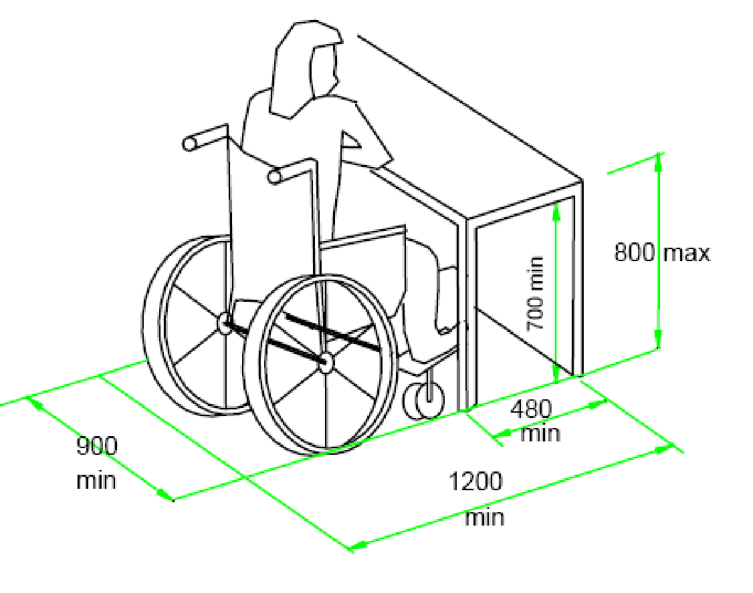

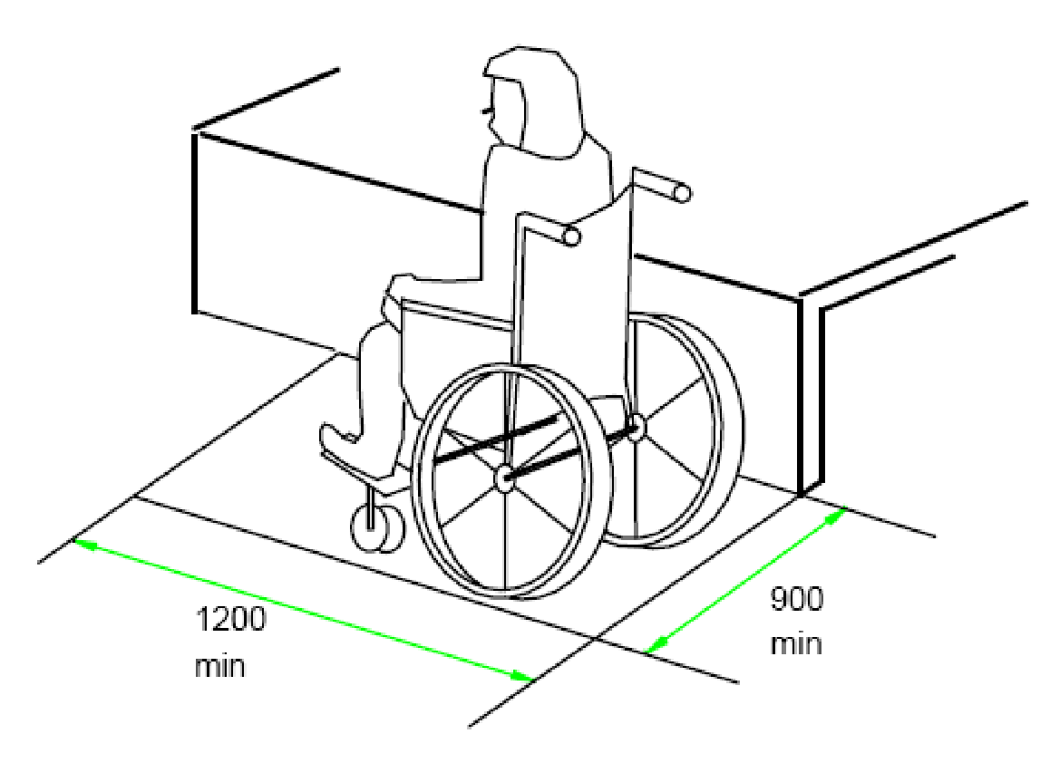

Counter
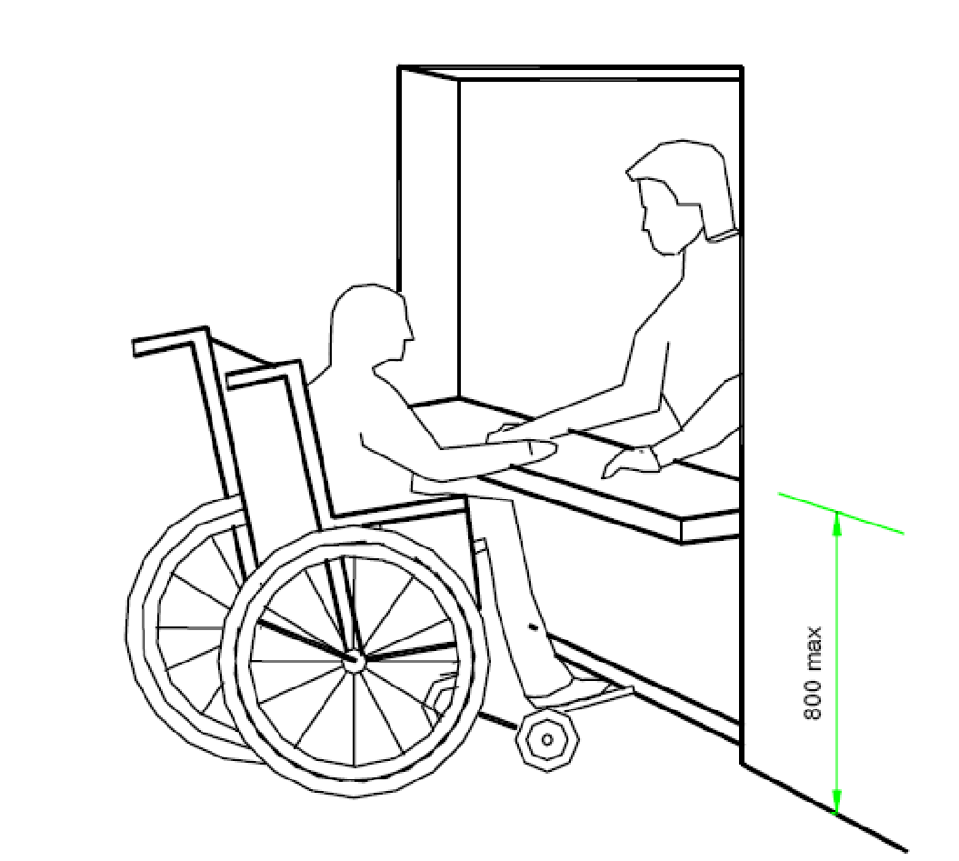

25. Public telephone booth and ATM service: The concern agency or organization should do following arrangement to make their public telephone booth and ATM services to be accessible for people with disabilities:
(a) There should not be any barriers for wheelchair’s entry into ATM room at public place. For this, door, ramp if needed and required space to rotate wheelchair after entering into the room should be available.
(b) Bottoms kept for ATM machine should be at maximum height of 30 inches from the wheelchair stepping surface.
(c) Numbers or commands mentioned on bottoms to be used for ATM machine should also be kept in Braille compulsory so that people who are blind can read them easily.
(d) Seating arrangement should be made for those people with disabilities who cannot use ATM machine by standing. Those seats can be made folding.
(e) There should not be any barriers to enter into public telephone booth and its use for people who use wheelchair.
(f) Hole to insert coin, telephone receiver and number bottoms for wheelchair user should be kept at maximum height of 30 inches from ground surface.

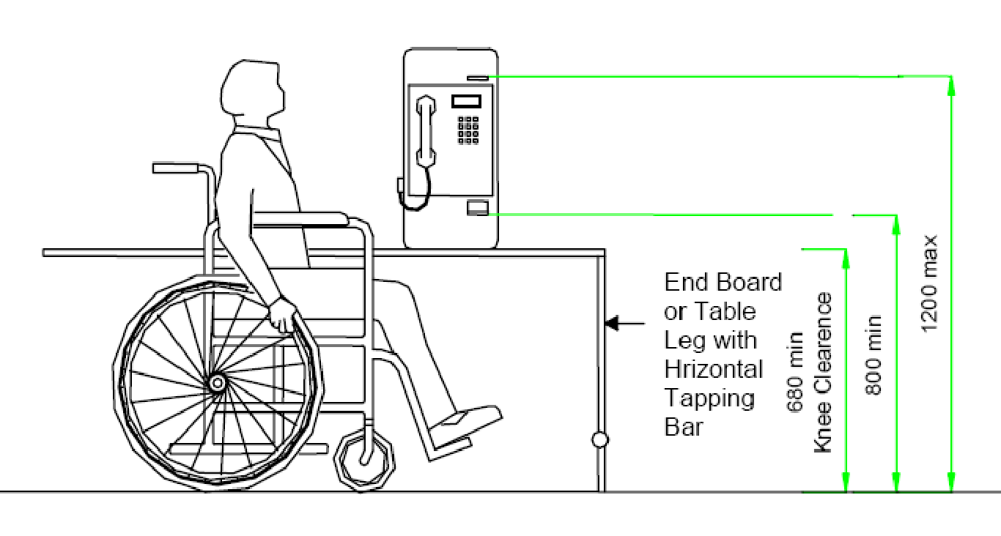
Accessible Telephone Booth
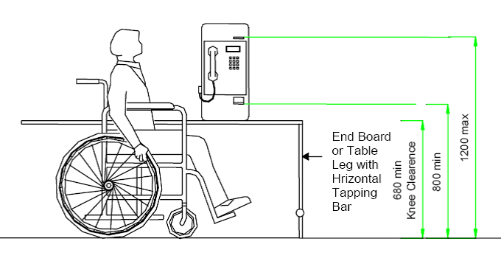

26. Vehicle parking: (1) At places designated for vehicle parking, out of every 10 parking lanes, at least one parking space should be made accessible compulsorily for people with disabilities and the clearly visible international standard accessibility signage should be kept in that space.
(2) While arranging the parking space for people with disabilities, at least 48 inches wide and 60 inches long space per scooter should be separated for special type of scooter and there should be at least 36 inches gap between the parked scooter and another scooter.
(3) In case of car, van, jeep etc, at least 96 inches wide and 188 inches long space should be separated for accessible parking and there should be at least 60 inches wide open space in between two parking vehicles.
(4) After parking the vehicle at parking space, there should not be any barriers to people with disabilities to go to their work by sitting on wheelchair or using other assistive devices and a ramp should be constructed if required for this happen.

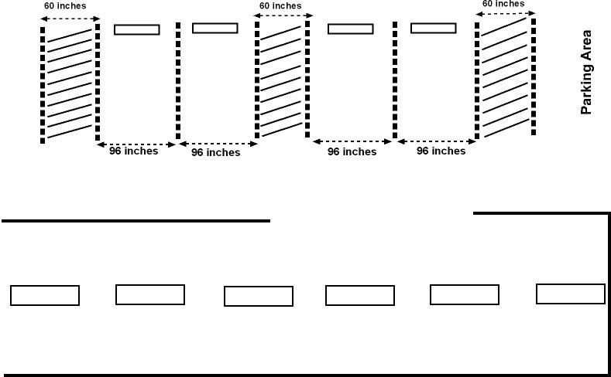
27. Conference hall and cinema hall: The concern agency or organization should do following arrangement to make public conference or auditorium hall and cinema hall to be accessible for people with disabilities:
(a) Any physical barriers should not be kept at entrance into public seminar, conference hall for people with disabilities including wheelchair user, crutches user, people who are blind.
(b) A ramp should be managed in such a manner that a wheelchair can easily goes upto the stage made for performing different activities inside seminar, conference hall.
(c) At audience lobby of conference hall, 5% of total seats should be made accessible for people with disabilities including wheelchair user, crutches user and other people with mobility impairment.
(d) To express ideas or to operate the program sitting on wheelchair or chair, at least one short podium should be compulsory managed in each seminar and conference hall. The height of such podium from its bottom surface to mike stand should be maximum 30 inches.
(e) There should not be any physical barriers at entrance into every cinema hall or theatre for all people with disabilities including wheelchair user, crutches user, and people who are blind.
(f) At audience lobby of each cinema hall or theatre, at least 5% of total seats should be made accessible for other people with disabilities including wheelchair user.
(g) A ramp should be managed according to need for reaching the wheelchair user without any barriers upto the program performing stage.

28. Ladder: (1) Ladders built in public buildings should be made comfort, secure and friendly to step up and down for people with disabilities including people who use crutches, caliper, prosthesis, elbow crutches, stick etc, and people who are blind.
(2) While constructing ladders in big business complexes including public place, guest house, private and public building constructed for various public service deliveries; the following standard should be followed to be accessible for people with disabilities:
(a) Each step of ladder should be equal width and equal height.
(b) Tread of step should not be less than 11 inches (280 mm) wide.
(c) The height of step should not be more than 6.5 inches (165 mm).
(d) Hand railing should be kept in both side of the ladder mandatory. If there is wall in one side or both side of ladder, the hand railing should be constructed keeping a gap of 1 to 1.5 inches between wall and hand railing.
(e) Height of hand railing (from each step from where railing starts to handling place) should be in between 34 and 38 inches (863 mm and 965 mm).
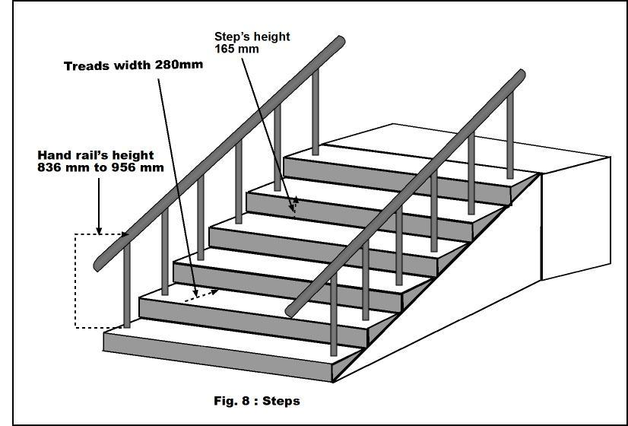
29. Lift: In modern buildings where lift is used to step up and down in the storey for people with disabilities, the following standard should be followed while connecting the lift:
(a) There should not be any physical barriers reaching wheelchair to lift from parking space or main gate or building premises.
(b) Wide of door in lift should be minimum 36 inches (915 mm) and minimum 48 inches (1220 mm) wide and 55 inches (1397 mm) long space should be available for one wheelchair inside the lift.
(c) Enough space required to rotate the wheelchair inside the lift should be ensured.
(d) Electronic buttons used for calling lift should be kept at maximum height of 42 inches (1066 mm) from the stepping surface of the wheelchair.
(e) The button required to switch on after entering into the lift to reach upto the wished storey should also be at maximum height of 42 inches (1066 mm).
(f) Letters written on buttons to be used to operate the lisf should also be written in large letters to be easily read by people with visual impairments and also in Braille that can be read by people who are blind.
(g) To know whether the lift is going up or down and to know in which storey the lift has reached, visual signal as well as listening beep signal should also be arranged.
(h) A horizontal grab bar should be kept at maximum height of 36 inches (915 mm) inside inner wall of the lift.

30. Water tap: While connecting public water tap, the following standards should be followed to be accessible for people with disabilities.
(a) In case of open tap built in public place, to use the water tap by sitting on the wheelchair, the height from wheelchair stepping surface to spout of the water tap should be maximum 30 to 36 inches.
(b) Water tap which is built with direct water fall to floor, the surface where water directly falls should be built in such a manner that the wheelchair or crutches shall not be sleepy.
(c) The place being built for keeping soap or brush near to water tap should be at maximum height of 30 inches from the ground surface.
(d) The height of clothes hanger’s hook should be at maximum height of 42 inches.
(e) While selecting water taps, water taps these are appropriate for all should be selected as far as possible.

31. Toilet: (1) There should not be any barriers for people with disabilities including wheelchair user to enter and use toilets constructed in any buildings for public use, toilets constructed in guest houses and any other toilets.
(2) The following standards should be applied while constructing toilet to be accessible for people with disabilities:
(a) If the leaf of door of toilet is being built to open the door outside, enough space should be kept outside the door to pull the leaf outside by a wheelchair user safely. An extra space is required to roll the wheelchair little back while pulling the door outside and entering into inside after the door is fully opened. Such extra space should be at least 60 inches long and 36 inches wide.
(b) If the leaf is built opening inside, there should be open space to rotate the wheelchair to close the door after entering into the toilet and standing on it and transfer to flush. There should be an extra space of at least 32 inches wide and 51 inches long inside toilet.
(c) Since traditional toilet (passing stool by squishing) is inappropriate and difficult for people with disabilities, commode (passing stool by sitting like in chair) which is appropriate for all should be used in public toilets as far as possible. While connecting such commode, its height from surface should be 19 inches maximum.
(d) In the notice place to point the place being toilet or to symbolize toilet, it should be written in Braille also and separation of female toilet and male toilet should also be written in Braille. Such Braille notice should be kept in maximum height of 42 inches from surface so that people who are blind can easily touch with their hands while standing.
(e) There should not be any barriers for wheelchair users to reach upto the urinal built in public male toilet.
(f) The height of urinal from wheelchair stepping surface should be maximum 30 inches.

32. Sidewalk: The following standards should be complied while constructing Sidewalk to be accessible for people with disabilities:
(a) In the place to be built for crossing the road, a curb ramp should be made to go up to the Sidewalks from the road after crossing the road.
(b) To avoid any barriers by wheelchair user to other people while rolling wheelchair and by other people to wheelchair user while walking in Sidewalk, at least 71 inches (1800 mm) wide of the Sidewalk should be ensured.
(c) There should not be any businesses including parking in the Sidewalk.

33. Tactile blocks: (1) To walk in confidence and comfortably by people who are blind in the street and to reach the destination without any confusion, specific standard, size and types of tactile blocks should be laid in street, Sidewalk, premises and main entrance of public building, public parks, school and college premises etc to know the arrival in these places by touching with white stick or feet.
(2) For requisite of Sub-Section (1), dotted type tactile blocks and line type tactile blocks should be used.
(3) The place to be used tactile block as follow:
(a) Street and Sidewalk,
(b) Bends in road,
(c) Juncture of four cross roads and road crossing place
(d) Link path from main gate to building or service delivery places in various public places or building premises,
(e) Ladder

(4) The following standards should be followed while constructing tactile blocks:
(a) Tactile blocks should be made of minimal sand, cement or stones.
(b) Tactile blocks should be easily recognized and understood by people who are blind through their feet or white stick.
(c) Tactile blocks should be in square shape and each block should be at least 300 mm or about 12 inches wide and 12 inches long.
(d) Dots or lines made in tactile blocks should be embossed which can be felt by people who are blind.

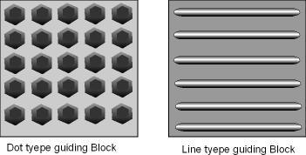

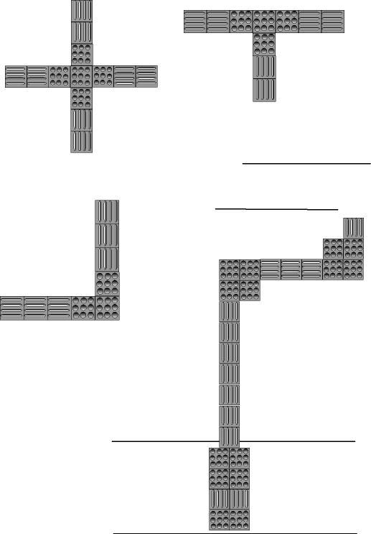

Chapter-6

Miscellaneous
34. Electricity pole, signboard, telephone booth, notice and information board to be kept without barrier: While keeping various things like electric pole, signboard, telephone booth, notice and information board, tree plantation etc in Sidewalk, passage, lobby or corridor of public building etc, the following arrangement should be made to avoid barriers to people with disabilities including people who are blind.
(a) Plant trees and sprout in street and Sidewalk only after leaving enough space for movement and the branches of trees these are grown up at least 7 feet below from the surface of road or Sidewalk and branches of trees expanded towards street or Sidewalk should be removed.
(b) Electric or telephone poles should not be kept in middle of the Sidewalk which create difficulties or hit while people who are blind are walking.
(c) Holes in Sidewalk should be filled up and big stones should be removed.
(d) Notice and informations board either keeping attach with wall or not, in passage or lobby of Sidewalk or big public building or other any materials while putting above 580 mm height should be put in such a manner that the body does not strike the object and at least wall can be found easily by white stick even if the objects cannot be found. For this, the edge or part of that objects should be 100mm outward through passage only.
(e) If such things are kept only in 580 mm high or less than that height, to find the things by white stick and to avoid possibility of hitting body, the portion towards passage or side should be more than 100 mm. There should not be any barrier to move in passage.
(f) Arrangement regarding use of voting right: During election period, from the process of voter registration to casting vote and physical structures shall be constructed and arranged in such a way that people with disabilities can easily reach upto the voting booth and use their voting right. For this, arrangement of ramp as per need, priority shall be given for those who cannot sit in queue for vote. To increase access of people who are blind to voting process and to make them confidence for their vote, practice of using ballot with Braille or accessible electronic voting machine shall be gradually implemented.
35. Reasonable Accommodation be available: The concern agencies, in addition to above mentioned barrier free environment and standards for people with disabilities, depending on individual functional limitation, physical condition and need, to access in physical structure or facilities of school, home or workplace without extra economic burden, should provide reasonable accommodation like special assistive devices, class room, toilet or bathroom, table and utensils for eating, arranging special sitting chair or desk, computer software, arrangement of key board and mouse to be used by feet for those who operate computer by their feet, racks, filing cabinet, telephone, printer, photocopy machine, scanner etc of workplace be with reasonable accommodation and appropriate way etc.

